**Assignment No. 05**

**Q.1. For your project draw DFD diagram.**

**1) Level 0 DFD**

**2)Level 1 DFD**

**3) Level 2 DFD (if required)**

**Ans.**

1. **Context Level DFD (Level 0 DFD):**

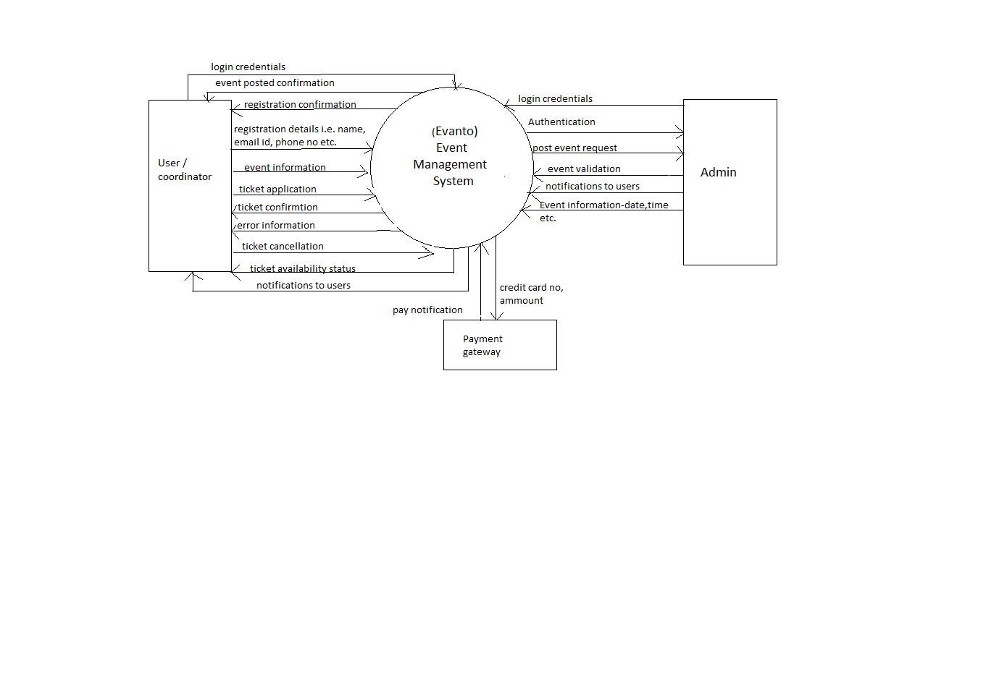

1. **Level 1 DFD:**

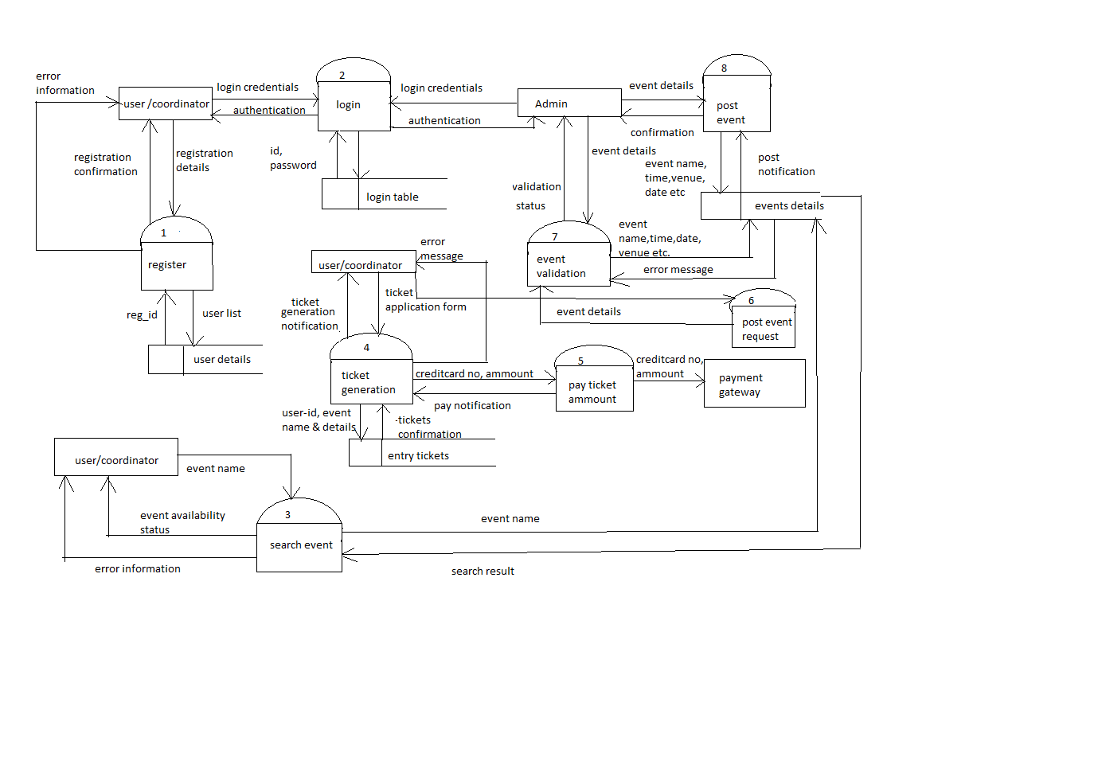

**Q.2. Transform the above DFD into structural chart.**

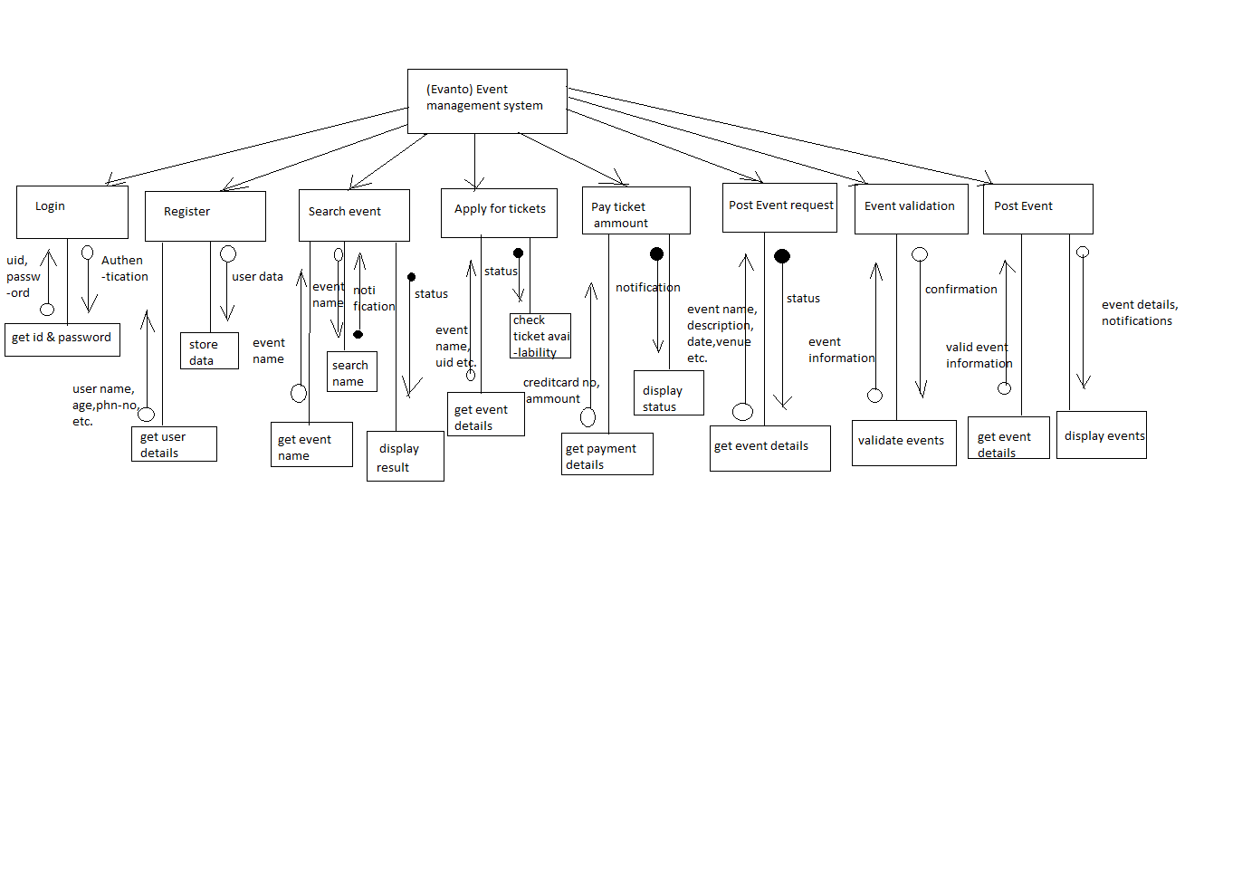

**Q.3 : Identify all data stores from DFD**

**1: Write data dictionary**

* **Login table**

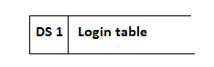

**Attribute and Datatypes:**

1. Aid- char (20)
2. Uid- char (20)
3. APassword- char (20)
4. UPassword- char (20)
5. ASecque- char (100)
6. ASecans-char(100)
7. USecque- char (100)
8. USecans-char(100)

* **User details**

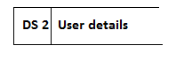

**Attributes and Datatypes**:

1. UName- Char (100)
2. Uid-char(20)
3. UAddress- Char (150)
4. UcontactNo. – int
5. Umailid-char(100)

* **Event details**

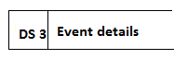

**Attributes and Datatypes:**

1. Aid- Char (20)
2. Ename- Char (100)
3. Edate-date
4. Etime-time
5. Evenue- Char(100)
6. Etype- Char(100)

* **Entry tickets**



**Attributes and Datatypes:**

1. Ename- char (20)
2. Eticketno – Char (100)
3. Etickammnt- int
4. **: Draw ER diagram:**

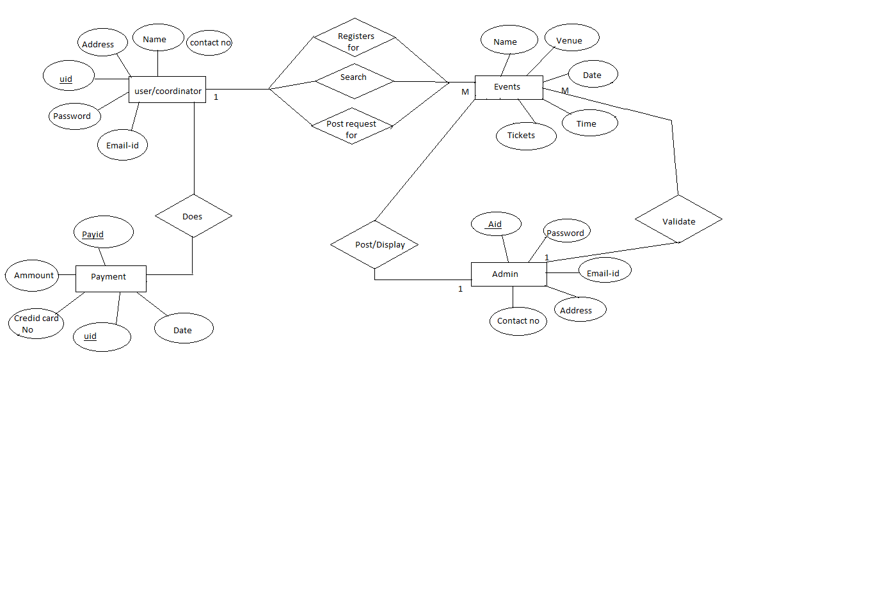

**3: Translate Model to physical Schema.**

1. **Create table login:**

**Admin:**

Create table Alogin

(

Aid char (20) not null

APassword char (20) not null

ASecque char (100) not null

ASecans char(100) not null

)

**User/coordinator:**

Create table Ulogin

(

Uid char (20) not null

UPassword char (20)

USecque char (100)

USecans char(100)

)

**User details**

Create table Userdetails

(

UName Char (100) not null

Uid char(20) not null

UAddress Char (150) not null

UcontactNo. int not null

Umailid char(100) not null

)

**Event details**

Create table Eventdetails

(

Aid Char (20) not null

Ename Char (100) not null

Edate date not null

Etime time not null

Evenue Char(100) not null

Etype Char(100) not null

)

**Entry tickets**

Create table Etickets

(

Ename char (20)

Eticketno Char (100)

Etickammnt int

)

1. **Select query:**

**Admin:**

Select * from Alogin where Aid=101;

Select Aid, Apassword from Alogin;

**User/coordinator:**

Select * from Ulogin where Uid=109 ;

Select Uid, Upassword from Ulogin;

Select * from Userdetails where Uid=109;

Select * from Eventdetails where Ename=109;

Select * from Eventdetails;

Select * from Etickets where Eticketno=112;

1. **Delete query:**

**Admin:**

Delete * from Admin where Aid=101;

**User/coordinator:**

Delete * from Ulogin where Uid= 109;

Delete * from Eventdetails where Ename= ‘ABC’;

Delete * from Userdetails where Uid= 109;

Delete * from Etickets where Eticketno= 112;

1. **Update query:**

**User/coordinator**

UPDATE Userdetails

SET Umailid=”Abc1998@gmail.com’

Where Uid=109;

**Events**

UPDATE Eventdetails  
SET Edate = 2/7/2017  
WHERE Ename=”ABC”;

UPDATE Eventdetails  
SET Etime = 8:00pm  
WHERE Ename=”ABC”;

UPDATE Eventdetails  
SET Evenue = “A road,matunga”  
WHERE Ename=”ABC”;